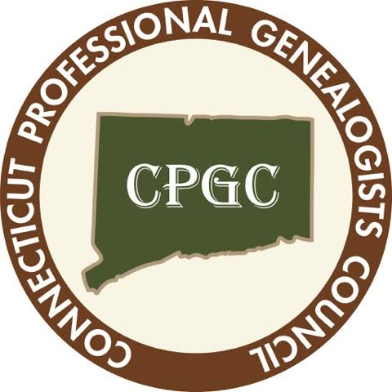

CPGC Meeting Agenda
Date: 1 February 2022
Topic: Publishing with Fred Hart & Barbara Mathews
Location: Zoom

REPORTS
Secretary – Minutes attached
Treasurer – Report attached
Membership
Corresponding Secretary
Donna Fund
Road Shows
Government Relations
Program
- 1 March – Pauline Merrick – Slavery in Connecticut
- 5 April – Roundtable discussion about future planning for genealogical collections
- 3 May – TBD
- 7 June – Walter Woodward
- 6 September – TBD
- 4 October – TBD
- 1 November – Annual Meeting & Potluck/Sharing
- 6 December – CSL Update with Mel Smith
NERGC
NGS Organization & Society Membership

UNFINISHED BUSINESS
Godfrey Scholar offer (report)
Public records inventory (report)

NEW BUSINESS

ANNOUNCEMENTS

